Peer KPI appendix: Nebius vs CoreWeave, IREN, Oracle (OCI), Nscale, Lambda and Crusoe
$ per MW-yr, contracted vs live MW, capex per MW. As of Fri Oct 9, 2026 (ET); frozen for Sun Oct 11 finals. Read from the locked team files (comparison.xlsx, peer_benchmark.xlsx, price_or_mw.xlsx, site appendices, model v0.9e); every value tagged [R reported | D derived | P press | E estimate | n/d]; superscripts = footnotes. Not a valuation; Nebius Q3'26 results ~Nov 10 (est.).
Company | Named-contract $M per MW-yr¹ | Company $/MW print ($M)³ | Rev / active MW (K01)⁴ | Fwd rev / billed MW⁴ | Contracted MW⁶ | Live MW⁶ | Contracted / live | Capex / MW (K13)⁹ | Net PP&E / MW (K14)⁹ | MW notes (key site)
Nebius | 14.49 Microsoft [E, house]; Meta #1 $11.52M [E, MW is a team estimate of ~50 IT MW]²,¹¹ | 20–25 (Q2'26 deals); >40 mgmt comment; base ~12 [R] | 11.92 [E] (Jun-26) | 23.13 all customers [D]; ex-MSFT hurdle 27.63 [D]⁵ | >3,500 [R] | 181.5→193 [E]; billed YE26 257.7/284.2, FY27 531.84/659.16 [D] | >18.1x [D] | 77.9 [E] | 67.6 [E] | IT/energized; contracted >3.5 GW is a lower bound (5 GW YE26 target) [R]
CoreWeave | n/d (no MW on any named deal) | ~40 (3–6-mo deals) [R] | 6.87 [D] (Jun-26) | 11.29 [E] (Street FY27 / base avg MW 2,325) | 3,700 [R] | 1,500 [R] | 2.5x [D] | 20.0 [D] | 31.2 [D] | IT-like active; ~4,200 contracted Aug-11 [R]; Denton ~260 IT live [D]
IREN | 9.7–11.3 (Microsoft IT; NVIDIA stated) [D] | >20 (3-yr); ~25 unsigned [R] | 7.05 [D] (Jun-26) | 13.33 [D (R/R)] (YE26 ARR $4B / 300 IT MW) | 260 [D]⁸ | ~40 [R] | ≤6.5x [D]⁸ | n/d | n/d | IT (AI); Childress ~75 IT active Oct [D, site]
Oracle OCI | 13.3 stated / 16.0 IT read (OpenAI) [P] | n/d | n/d | 14.42 [D/E] (OCI annualized / ~2,050 cum. MW) | >10 GW [R, FQ1 FY27 call Sep 10]⁷ | ~2,050 [E]⁷ | n/d⁷ | 46.4 [E] | n/d | cum. delivered (likely gross); '>10 GW secured'; Port Washington 0 live [R]
Nscale | 11.7–16.2 (Narvik D; MSFT 13.4 P; Anthropic P) [D / P] | n/d | 3.47 [D] (2026-06-30) | n/d | 1,370 [R] | ≤81 [D] | 16.9x [D] | n/d | 70.7 [D] | IT; Monarch 460 IT contracted / 0 live [R]
Lambda | 16.7 Anthropic (band top) [P] | n/d | 9.70 [D (P inputs)] (2025-06-30) | n/d | n/d | 47 [P] | n/d | n/d | n/d | unstated; Beacon Point ~350 [P]; KC ~12 IT live [E]
Crusoe | n/d (no value with MW) | ~23.3 per gross MW, whole term (not /yr) [D] | 2.00 [E] (2026-09-17) | n/d | 6,000 [R] | ~1,000 [R] | 6.0x [D] | n/d | 12.5 [D] | GROSS; Abilene 618 IT live of 1.2 GW gross [D on R]
Peer median | band 9.7–16.7 (Nebius excl.)¹ |  | 6.87 [D] |  |  |  | 6.0x [D] | 33.2 [D] | 50.9 [D] | comparison.xlsx sets; IREN ratio and Crusoe K14 excluded
Bitdeer AI (ref.) | ≤22.4 A201 Johor, ceiling [D, basis P]¹⁰ | n/d | n/d | n/d | ≥15.2 of ~21.7 [R] | 0 [R] | n/m | n/d | n/d | not one of the six; energized Q1'27–Q1'28

NEBIUS LOCKS (model v0.9e, asserted by the build): Microsoft $14.49M per IT MW [E, house] (Contracts!E12) only · ex-MSFT hurdle $27.63M [D] · $23.13M = Street FY27 ÷ our 531.8 billed MW, all customers [D] · clear-spot $24.51M / $22.68M · turn-positive $17.05M / $16.70M · energized 181.5→193 MW [E] · billed YE26 257.7/284.2, FY27 531.84/659.16 [D] · K13 capex/MW 77.9 vs peer median 33.18 · comp band $9.7–16.7M · Bitdeer ≤$22.4M is the only disclosed-MW print ≥ $20M.
HEADLINES: Nebius: ex-MSFT hurdle $27.63M is ~1.7x the band top; live 193 MW vs >3.5 GW contracted (18.1x); capex/MW 77.9 vs median 33.2. | CoreWeave: no MW on named deals; ~$40M print is 3–6-mo pricing; 2.5x contracted/live; lowest capex/MW (20.0). | IREN: named 9.7–11.3 (band floor); >$20M only on 3-yr deals; 260 vs ~40 MW. | Oracle: OpenAI 13.3–16.0 [P]; >10 GW secured vs ~2,050 delivered; capex/MW 46.4. | Nscale: 11.7–16.2; ~17x contracted/live (≤81 live). | Lambda: Anthropic 16.7 sets the band top [P]; company MW n/d. | Crusoe: no per-deal $/MW; ~$23.3M is whole-term per gross MW; 6x.
1 Named contracts = TCV ÷ term ÷ MW, IT MW where disclosed, else stated MW (comparison.xlsx Contracts_$MWyr cols V/W = peer_benchmark.xlsx Contracts col K, asserted equal). Comp band $9.7–16.7M = IREN-Microsoft 9.7 to Lambda-Anthropic 16.7 (P, Medium); same ends on the memo set (P1/NEW1/P2/O1/NEW2/O2, Nebius excluded) and on GPU Market's eight band prints (incl. Nebius-Meta #1 11.52 and Nebius-Microsoft 14.49).
2 Nebius-Microsoft $14.49M per IT MW [E, house] = model Contracts!E12 = 17,392.9 / (5 x 240 IT MW est.); neither company states the contract MW (300 MW = Vineland site size). Agrees with the Drivers 14.5 input.
3 Company prints are not single contracts; MW basis undefined; short tenors and GPU-inclusive pricing. Nebius >$40M = management comment on Q3-to-date short-term pricing (Q2'26 letter KPI chart; CEO on the Aug 12 2026 call), not reported Q3. Crusoe ~$23.3M is whole-term TCV per GROSS MW, not per year.
4 K01 = latest-quarter segment revenue x4 ÷ period-end active MW (comparison.xlsx; bases differ: Crusoe FY26E revenue / ~1 GW gross; Lambda Q2'25 press). Fwd = price_or_mw.xlsx Implied_Price (FY27 or run-rate ÷ avg billed MW).
5 Nebius hurdles (model v0.9e) are REQUIRED revenue per billed IT MW: ex-MSFT $27.63M (Drivers!B9, peer comparator); $23.13M = Street FY27 ÷ our 531.8 billed MW, all customers [D] (Drivers!B10, memo); clear-spot $24.51M / $22.68M (Drivers!B6 / Debate_Grid!A18); turn-positive $17.05M / $16.70M (Debate_Grid!A13 / A10).
6 MW bases are mixed (IT vs gross). Nebius live = energized 181.5 -> 193 MW (Q1 -> Q2'26, Capacity base case, E); contracted >3.5 GW is a lower bound (R). Billed IT MW (model v0.9e): YE26 257.7 / 284.2; FY27 avg 531.84 / 659.16.
7 Oracle contracted/live n/d. Contracted '>10 GW secured' [R, FQ1 FY27 call Sep 10] (not a filed contract figure). Live ~2,050 = AI MW delivered since Jun-25 (E; peers/oracle Inputs!P48 I45E); installed base n/d.
8 IREN contracted/live ≤6.5x [D] (upper bound; not in the median). Live = ~40 MW AI Cloud operating capacity at Jun 30, 2026 (FY26 10-K, R), company-wide; excludes Horizon 1 (50 IT MW, accepted Aug 13). Childress ~75 MW active (Oct, D) is one site and not used. Contracted ~260 IT = Microsoft 200 + NVIDIA ~60 (D).
9 K13 = trailing-4Q cash capex ÷ trailing-4Q new active MW; K14 = net PP&E ÷ active MW (comparison.xlsx). Nebius capex funds not-yet-live MW (Worse vs median). Crusoe K14 = Abilene JV shell+power only, excluded from the median.
10 Bitdeer A201 <= $22.4M is a CEILING (contracted MW is a floor: >70% of ~21.7 MW; 15.7 if 100%); MW basis P. It is the only contract with disclosed MW at >= $20M/MW (peer_benchmark Contracts; comparison has none).
11 Nebius-Meta #1 $11.52M [E, MW is a team estimate of ~50 IT MW] = $2,880.7M / 5 / ~50 (comparison.xlsx N2 = peer_benchmark N2). Sources: GPU Market market/contract_economics.xlsx Print_Table #3 and final band slide (contract_band_slide_final.png); Nebius filings and Capacity (Capacity tranches G3:H3 = n/d) state no MW; model Contracts!D23:D24 = 48.0 IT MW. One of the eight band prints; band ends unchanged at $9.7M / $16.7M.
Sources: comparison.xlsx; benchmark/peer_benchmark.xlsx (+ its Sources keys: SEC 8-K/6-K/S-1, company PRs, WSJ/Reuters/Bloomberg); price_or_mw.xlsx; sites/sites.xlsx + site appendices; model/nebius_model.xlsx v0.9e; capacity/nebius_capacity.xlsx. Full list: peer_kpi_appendix.xlsx Sources tab.

Charts: $ per MW-yr vs Nebius hurdles; contracted vs live MW; capex per MW vs peer median
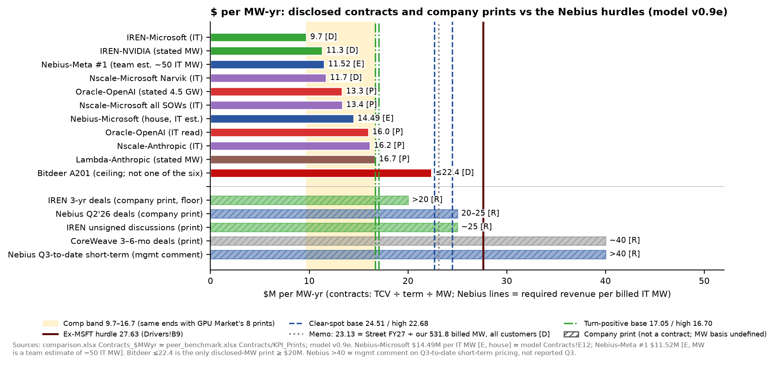
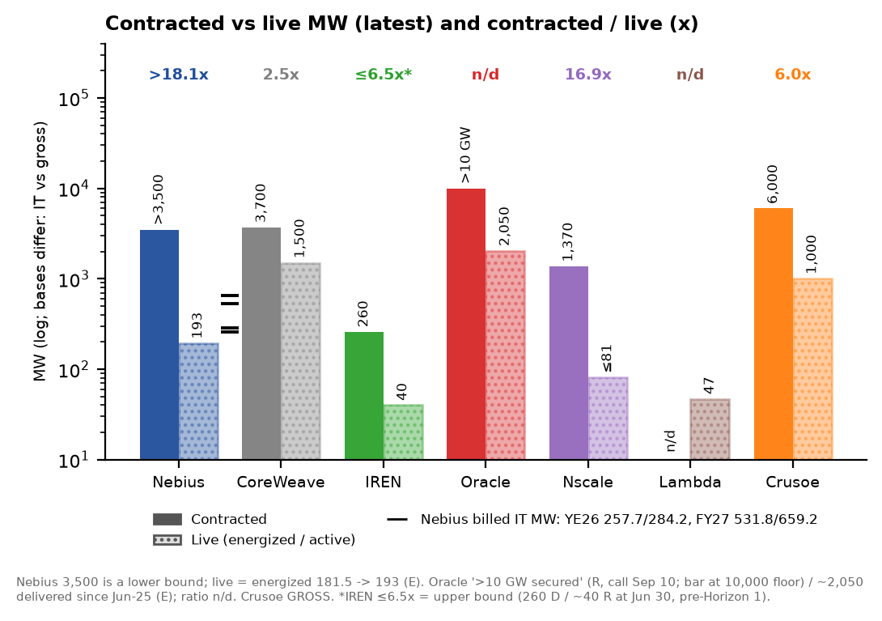 | 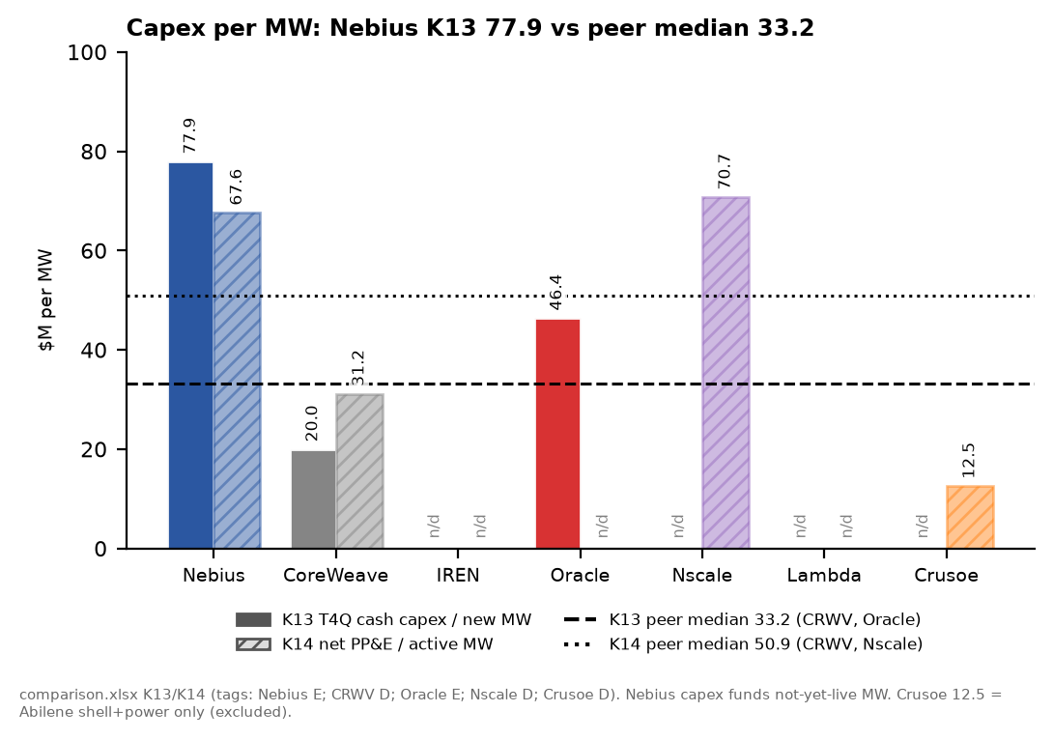
All values from the table on page 1 (same files, same tags). Charts are context for the appendix table, not new estimates.

